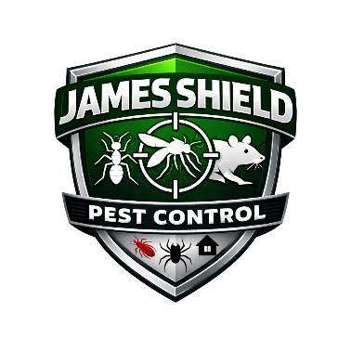
James Shield Pest Control
Workplace Conduct & Ethics Policy

1. Purpose
James Shield Pest Control is committed to maintaining a professional, respectful, and ethical work environment. This policy establishes standards of conduct and outlines expectations for employee behavior, both in the workplace and when representing the Company.
All employees are expected to conduct themselves in a manner that promotes integrity, respect, safety, and compliance with applicable laws.

2. Scope
This policy applies to all employees, supervisors, managers, contractors, and any individual representing James Shield Pest Control.
This policy applies to conduct occurring:
- At Company facilities
- At customer locations
- During business travel
- At Company-sponsored events
- While using Company Electronic Communication Systems (ECS)

3. Standards of Conduct
Employees are expected to:
- Treat coworkers, customers, vendors, and the public with respect.
- Maintain honesty and integrity in all business dealings.
- Comply with all Company policies and applicable laws.
- Protect Company property and confidential information.
- Perform job duties responsibly and professionally.
- Promote a safe and inclusive work environment.
Failure to adhere to these standards may result in disciplinary action.

4. Prohibited Conduct
The following behaviors are strictly prohibited:
- Discrimination based on protected characteristics (including race, color, religion, sex, national origin, age, disability, genetic information, or other protected categories under applicable law);
- Harassment, including sexual harassment;
- Bullying or intimidation;
- Workplace violence or threats of violence;
- Theft, dishonesty, or fraud;
- Insubordination;
- Use of illegal drugs or being under the influence while at work;
- Retaliation against employees who report concerns in good faith.

5. Electronic Communication Systems (ECS)
James Shield Pest Control strives to maintain a workplace free of discrimination and harassment. Therefore, the Company prohibits the use of its Electronic Communication Systems (ECS) for:
- Bullying or harassment;
- Discriminatory communications;
- Threatening or abusive language;
- Sharing offensive or inappropriate content;
- Engaging in unlawful misconduct.
ECS includes, but is not limited to:
- Company email systems
- Messaging platforms
- Company-issued phones
- Company-issued laptops
- Internal collaboration systems
- Social media when used for Company business
All communications using Company systems must reflect professionalism and compliance with Company policies.
Employees should have no expectation of privacy when using Company ECS, to the extent permitted by law.

6. Anti-Discrimination & Anti-Harassment Commitment
James Shield Pest Control is committed to maintaining a workplace free from discrimination and harassment.
Any employee who experiences or witnesses conduct that violates this policy must report it immediately to:
- Their supervisor; or
- Human Resources; or
- Senior management.
Reports will be investigated promptly and confidentially to the extent possible.
Retaliation against any individual who makes a good-faith report is strictly prohibited.

7. Conflict of Interest
Employees must avoid situations that create actual or perceived conflicts between personal interests and Company interests.
Employees must disclose potential conflicts to management, including:
- Outside employment that interferes with Company duties;
- Financial interests in competitors or vendors;
- Personal relationships that may influence business decisions.

8. Professional Representation
Employees represent the Company when interacting with customers, vendors, and the public. Employees are expected to:
- Maintain professionalism;
- Avoid conduct that could harm the Company’s reputation;
- Adhere to ethical business practices.

9. Reporting Violations
Employees who become aware of violations of this policy must report concerns promptly.
The Company prohibits retaliation against employees who report misconduct in good faith.
Failure to report known violations may result in disciplinary action.

10. Disciplinary Action
Violations of this policy may result in disciplinary action up to and including termination of employment.
The Company reserves the right to determine appropriate corrective action based on the severity and frequency of misconduct.

11. Administration
James Shield Pest Control reserves the right to interpret, modify, amend, or terminate this policy at any time, consistent with applicable laws.

